**Phone:**



613-480-6258

**QUINTE**

**EYE CENTRE**

**Fax:**

613-480-0262



**Email:** [quinteeyecentre@hotmail.com](mailto:quinteeyecentre@hotmail.com) **Address:**

Unit 102, 121 Dundas Street East,

Belleville, ON, K8N 1C3

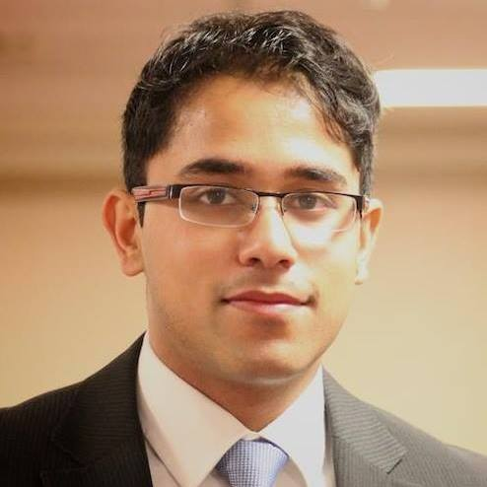

**DR. RITESH GUPTA MD, FRCSC**

**MEDICAL DIRECTOR**

**QUINTE EYE CENTRE**

Dr. Ritesh Gupta obtained a Bachelor of Health Sciences degree at McMaster University. Following this, he completed a Doctor of Medicine (MD) degree at University of Toronto. He completed his Residency in Ophthalmology at University of Western Ontario. He then completed a fellowship in Cornea and Refractive Surgery at Loma Linda University in California, USA.

**ACCOMPLISHMENTS AND AWARDS**

* Dr. Gupta received multiple awards for his research work as well as international missions with a focus on global ophthalmology.
* Dr. Gupta has published numerous research articles and presented at various national and international ophthalmology conferences.
* Dr. Gupta is involved in the creation of surgical and teaching videos, several of which have been featured in various Ophthalmology conferences.
* Dr. Gupta is an avid tennis player, having won various tournaments and represented McMaster University in varsity competitions.

**SERVICES PROVIDED**

* Dr. Gupta provides comprehensive ophthalmology services for the Quinte Region including emergency on-call services. He performs cataract surgery and provides Medical retina care including intravitreal treatment on-site at the Quinte Eye Centre. Referrals can be faxed to: 613-480-6258.